The Good News

A Newsletter of St. Paul’s Episcopal Church, Louisville, Kentucky

# 

# **Wherever we are, this is how we love God and God’s People**

# From the Rector’s Study

## Fr. Andrew, Rector

Beloved,

M

ay was a busy month of transition. As Mrs. Erin called each child by their name at the graduation, the student walked up to the front, gave the teacher a big hug, received a beautiful, handmade prayer blanket —a symbol of God’s love, and stood still by themselves in front of everyone with a tiny academic hat on top of their head for a proud Kodak moment. They were much taller and more confident, and were nothing like when they first set foot in the preschool. Their lives are forever changed. As the preschool sent the children off on their next journey, the prayer blanket reminds them of their rich experience packed with memories of loving teachers, friends, much laughter, and a few tears. It wraps around them to bring comfort. It can be their cape, reminding them of their superpower. Watching the faces of all the graduates, their families, and the teachers glowing is truly infectious and inspiring.

A few weekends before the preschool graduation, the annual spring planting of our memorial garden took place. I was feeling uneasy as the weekend approached without knowing how many helpers we’d get. Contrary to my fear, many more helping hands showed up this year to beautify the garden and pay respect to our old friends. The youngest helpers are Avery and Autumn. Autumn is our first JOB scholar graduate, and Avery is about to begin in our preschool following his sister’s footsteps.

As I highlighted at the parish picnic, the blessings and dedications of the spiritual pathway, the renewal of the playground, and the memorial garden make us aware how this faith community truly emboldens people from all walks of life, from the beginning to the end, and somewhere in between. We remind each other that Christ, the Alpha and Omega, is present in our midst through our relationships with one another.

June, July, and August are periods of spiritual recalibration.

We begin an ordinary time after celebrating **the Day of Pentecost on June 8th (Remember to wear Red on Pentecost!)**. Your vestry leaders will start preparing for the program budget for the coming year, as well as the audit work to ensure the health of our stewardship. We also have major construction work planned this year to install a new lift, expanding the accessibility of our building to all who utilize our facility. Thanks to your incredible generosity, we are able to take action to achieve this significant milestone. I am truly blessed to have the privilege of serving in this faithful community alongside you all. With God’s help, walking the spiritual journey of faith, we will be and lead others to be committed followers of Jesus Christ. Loving God and His people as Jesus commended us, lifting each other’s hearts to the Lord, makes this faith community truly beautiful. Let us continue to do good work in love that glorifies our God.

Love in Christ,

Fr. Andrew

**+**

# From the Deacon

Pete Womack – Deacon

O

n Monday, May 12th, 59 white South African farmers (Afrikaners) arrived in the US, because according to the President, they were being persecuted in South Africa. They were said to be political refugees, despite no news of any sort of persecution being reported inside or outside of South Africa. While they are a minority, making up around 7% of South Africa’s population, they own around 80% of the farmland, giving them continued economic influence after losing political dominance with the end of apartheid. Shortly after their arrival, the Episcopal Church refugee relocation service was asked to help with settling the Afrikaners as a requirement of a refugee settlement grant from the government. Presiding Bishop Sean Rowe released a [statement](https://www.episcopalchurch.org/publicaffairs/letter-from-presiding-bishop-sean-rowe-on-episcopal-migration-ministries/) saying that the Episcopal Church would not provide assistance because, “In light of our church’s steadfast commitment to racial justice and reconciliation and our historic ties with the Anglican Church of Southern Africa, we are not able to take this step.” This is now the [second time](https://www.ncronline.org/opinion/editorial/editorial-addressing-trump-bishop-budde-did-what-christian-obliged-do) that the church has confronted the President and his policies over their unfairness and questionable moral foundation. I could not be more proud of my church at the moment.

We hold a core belief that is founded on the [second commandment](https://www.biblegateway.com/passage/?search=Luke%2010%3A25-37&version=NRSVUE) from God and the following parable of the Good Samaritan in Luke chapter 10, that there is no qualification of who our neighbor is that we should love as much as we love ourselves. The President has made it clear that our generosity should go only to those who are of white European ancestry to the exclusion of other races or ethnicities. That other non-white refugees and non-white residents of the US have been denied entry or deported shows blatant, unapologetic racism and white supremacy condoned by the President. These attitudes and beliefs go against what we, as Christians, are taught by Jesus in scripture regarding [humility](https://www.biblegateway.com/passage/?search=Matthew%2020%3A20-28&version=NRSVUE) (the last will be first in the kingdom of God) and the unconditional love of God ([healing](https://www.biblegateway.com/passage/?search=Mark%207%3A24-30&version=NRSVUE) the Syrophoenician woman’s daughter).

President Trump is not acting completely from his own belief, however. Many of his supporters do not see a problem with favoring white Afrikaners over Middle Eastern or Central Asian refugees, or a problem with choosing to remain silent where they do see a wrong. They appear to be motivated by fear of losing their privilege (the first will be last in the kingdom of God), or assume that the world is zero-sum, where someone else’s gain means they must lose something because of some ill-defined limited resource. What informs Presiding Bishop Rowe’s statement is the belief that the kingdom of God is not subject to human limitations, and that there is a place at the table for all who come seeking care, protection, and safety that comes from God’s love. We do not share our Christian brothers’ and sisters’ [emphasis](https://www.biblegateway.com/passage/?search=Mark%2013%3A21-27&version=NRSVUE) that Jesus is returning very soon to wipe away all sin and bring the kingdom to the true believers. We [emphasize](https://www.biblegateway.com/passage/?search=Luke%2019%3A1-10&version=NRSVUE) instead that Jesus said that the kingdom is near and is already here when we follow his way of life. We have to be sure that we make room for those among us who feel that they have been excluded and left behind in favor of non-white refugees, whether it is true or not.

There will always be fear of the unknown, the unfamiliar, and of difference. There will always be a sense of unfairness when others unlike us are given favors. But, if we are to trust in Jesus and trust in God, we have to trust in them and the Holy Spirit to show us where injustice lies, even when it seems to be in contradictory situations. It is only then that we will see the kingdom and feel comfortable sharing it with our black, Arab, Asian, Latino, and white neighbors.

**+**

# From the Buildings & Grounds

George Busch – Buildings & Grounds

D

ear Congregation of St Paul’s:

George Busch

I want to share my thoughts with you about the future of St. Paul's as far as caring for the buildings and the grounds. I have been at St. Paul's for going on twenty years and I want to share with you my observation and experiences. People have always volunteered to maintain the buildings and the grounds the best they could and have served on the vestry doing this. In the last 25 years it has been 5 rotating on the vestry every 3 years, John Weigand, Ray Brown, Bud Danimiller, Andy Graves and me. Bud moved away several years ago and the rest of us are not getting any younger. There is a real need for some younger people to consider helping in this capacity being on the vestry as well as helping around the grounds and in the building. There are 3 main people now that cover most of the work. We are all willing to continue to do this as long as we can, but our age is catching up with us.

Anyone who would choose to help doesn't have to know everything that we do but we who do it now could teach others stepping up and so called “pass the torch". If the church were to pay for everything, we do volunteer it would be a hefty expense. I've been getting prices for a custodian and prices for a landscape company to maintain the grounds like they are kept now. In talking to surrounding churches, I have come up with some prices and learned what a custodian generally does. They do light repairs like change bulbs or maybe a fixture, a leaky faucet, lite cleaning, and handle calling contractors for repairs. The cost for this is about $50,000.00 for a full-time person on a salary per year or around $15.00 / hr. for a part-time person. We would need a person at least 20 hrs. a week at a min cost per year of $15,600 per year. Also, they generally don't do any lawn work except pick up trash. A lawn service company to maintain all our grounds would be a minimum of $1000.00 / month, April through November at a Minimum cost of $8,000.00 a year. Right now, a lot of everyday maintenance expenses are covered by the people doing the work which I estimate to be around $5000.00/ yr. That is a total of $28,000.00 / year with added expenses for additional contract labor. So, anyone thinking you might want to help with caring for St. Paul's, don't be afraid to take the next step, we're all in this together as a family.

**Future repairs at St Paul's**

Here is a list of upcoming repairs that's going to be needed around the church in the next 5 to 7 years. The prices stated are today's prices and will be a bit higher in the future due to inflation.

-Seal driveway and parking lot, repair cracks and restripe, needed spring 2026 $10,890.00

-Gutters/leaf guard and downspouts needed within 5 years. There are about 500 lbs. of copper guttering that we can sell for scrap which is 3.25/lb. today, $1625.00. They would be replaced with 7" brown aluminum gutters and downspouts. Cost today $23,000.00

-New shingle roof on preschool wing within 7 years, today's price $24,000.00.

-Ongoing maintenance on the slate roof on the main sanctuary about $2000.00 per year average.

-2 new air conditioning units, one for the back of church and one for the preschool hallway and classrooms. They are about 20 years old, 3 have already been replaced, we have a total of 5. Today's cost is estimated at $24,000.00.

-Replace the concrete entrance, stairs and ramp in the front of the church within the next 5 years. Estimate at today's cost $40,000.00.

-Ongoing boiler pipe repair. Our pipes for heat are 62 years old installed with the old boiler in 1963. We see the need for repairs almost every year. For example, in 2024/2025 we had to replace 2 sections of pipes and 4 air bleed units at a cost of about $5000.00. Therefore, I think it's safe to say expect $2000.00 to $3000.00 per year for pipe repairs. This does not include the cost for annual boiler inspection and cleaning and the water treatment service we now have.

**+**

# From the Choirmaster

David Paul Gibson – Organist /Choirmaster

W

hat is one to say about June, the time of perfect young summer, the fulfillment of the promise of the earlier months, and with yet no sign to remind one that its fresh young beauty will never fade." - Gertrude Jekyll

Perhaps less romantically, in Rodgers and Hammerstein’s CAROUSEL we have that great Broadway song, “June is Bustin’ Out All Over!” What a great way to celebrate the coming of summer.

I have always felt that June is the month in which Kentucky is at its loveliest. It is also a month for retooling the Music Ministry. Following our fun post-Easter choir party, the Choir and Schola are now on their summer schedule. Unlike most church choirs, the members of our Choir and Schola have agreed to sing for worship throughout the summer months. It would be hard to imagine our worship without them! Things may be a bit different in the **A group of people posing for a photo
**choir loft as people vacation over the summer, but we will soldier on to continue to bring beautiful music each Sunday.

If you have ever considered joining the choir, there is no time like the present.**morning at 9:30am for the 10:30am mass. No pressure, just the pleasure of making music with these lovely people. If you might be interested or have any questions, please feel free to contact me at any time.

L.M. Montgomery tells us that "June is the pearl of summer, shining with warmth and joy."

I wish each of you much warmth, joy and many blessings in the month ahead.

# From the Memorial Garden

Sandi Pierie – Memorial Garden Chair

C

an you believe it is spring again??? This is one of my favorite times of the year. Everything is getting green and renewed. On May 10th, 2025 at 10am, we did our spring planting of flowers which were purchased from our preschool fundraiser. We had our regular planting group of the following: Fr. Andrew (Rector), George Busch, Ray Brown, Andy Graves (Building and Grounds), Penny Southwick (a gardener at heart), Ellie Stump, Marilyn Sadler, Sandi Pierie (Memorial Garden committee), Minnie Naive (Past Memorial Garden

Head).

This year was a little different, Fr. Andrew decided to do a little recruiting to get more help. Actually nine more participants, Athena Richardson (former choir member), Gabby Hillerich (Choir and her mom Melissa), Raju Chinta, (new member of St. Paul), Anna Miner and two children, Autumn and Avery, (members and a preschool student who graduated on May 16th), Olivia Benner (a member and her boyfriend Malaki) and now we have a total of 18, yes, I said 18 helpers. George had tilled the garden earlier in the week and had the holes for our flowers already when we arrived. We got down to the business of the day of planting eight flats with thirty-six cells of impatiens, along with 6 hardy-dragonfly begonias. Now we had to spread forty bags of mulch. All of this was completed in one hour and thirty minutes. THIS WAS A RECORD TIME.

This is why St. Paul can say “We Love Our Church”. Thank you all for the time and help you gave, but more important was the Fellowship and getting to know you all.

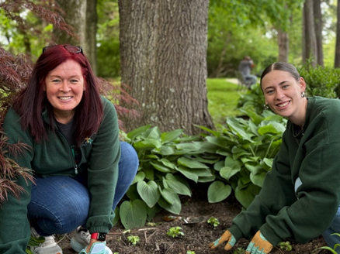

**Pray, Learn, Serve, and Rejoice at St. Paul’s**

### **We Pray**

**Pray for All**

During this challenging time, please be intentional about setting a time to pray. Pray for those on the prayer list. (pg. 13)

**+**

### **We Learn**

**A Weekday Formation Group**

Currently on Sunday morning at 9:00 A.M., an adult formation group has been offered for those who prefer an early morning group on Sunday. Those interested in this setting and time are currently reading and discussing How We Learn to be Brave authored by Bishop Mariann Budde. We have identified the need for a similar group that will take place during the week and at a time that is more flexible. If you are interested in such a group, please talk with or text Fr. Roger to be contacted to learn more about this option for study and growth.

**Ecclesiastical Bits & Bytes**

**Fr. Andrew**

Are you feeling intimidated with your computer, tablet, and smartphones?  Are you frustrated with virtual meetings?  Greetings, favored one.  Do not be afraid for the Lord is with us. Contact the office to set up an appointment.

**+**

### **We Serve**

**Calvary Episcopal Church Food Pantry**

Please join us at St. Paul’s Episcopal Church each Sunday from 9 am – 12 pm for the Sunday Service food collection.

All food is counted and delivered to Calvary on Thursday morning after collection. If you would like to volunteer to help with driving and delivery, contact Ray Brown or David Dawkins.

**Current Total: 161,297 items donated.**

**Please be a part of this amazing ministry by bringing items to the Sunday “SERVICE” at St. Paul’s or sending in your monetary donation!**

**St. Paul’s parish has generously donated over $15,418.35 to the Calvary Food pantry since June 2020. Make checks payable to St. Paul’s.**

**+**

### **We Rejoice**

**Website**

Communication is the key to a successful ministry. Be sure to check out the website to keep up to date on church activities.

**+**

.

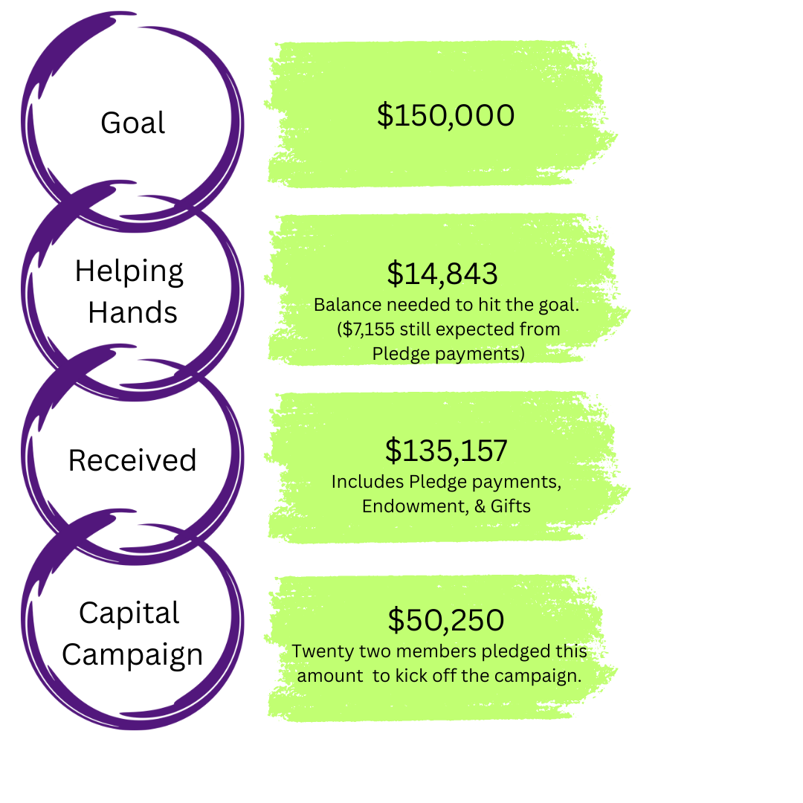

**Prayers and Thanksgivings**

*Please contact the office to include names on the prayer list by the 15th of each month. Names will be listed for 30 days (short term prayers) or if requested 3 months (long term prayers). Fr. Andrew and the weekday prayer group prays for each person by name every day.*

|  |
| --- |
| **Healing, Comfort, Relief, Protection, and Hope**  Jeanne & Jerry Powell, Vicki Kurk, Wanda & John Wiegand, Don & Joy Hauss, Matthew (Frind of Fr. Andrew), Jude Howell (Grandson of Donna & Al Smith), Dr. Oliver (Friend of Marilyn Sadleir), Theresa Goatley, Pat Ingelhart (Friends of Peggy Pryse), Ann Ford, Barbara & Alan Johnson, Lisa Johnson (Daughter-in-Law of Barbara & Alan Johnson), Dianne Hart (Sister-in-Law of Cindy Miner), Will Bearden (Friend of Robyn Fischer), Evan Hayen (Friend of Ann Ford), Pam Dickmann, Andy & Ann Norman (Friends of Mae & James Fleming), Paul Given (Brother-in-Law of Nancy Northrop), Lynn Green, Brad Beard, Jerry Nazarro, (Friends of Cindy Miner), Rona Bruce, Bill & Diana Motsch, Dena Rogers (Friends of Peggy Pryse), David Ford (Son of Ann Ford), Markie June Neal (Granddaughter of Monica Bell), Penne Wright (Sister of Suzie Aebersold) |
| **Serving in the Military**  2nd Lt. Kyle Sears (Grandson of Arlene Buckner), Christopher Neal (Son-in-law of Monica Bell), Anthony Polio (Grandson of John and Wanda Wiegand), John Phipps (Nephew of Ray Keller), Matt Hartmann, Luke Hartlage (Son of Linda Hartlage, preschool teacher), Jennifer & Joe Venghaus, Lt. Erin Jones (Niece of Rex Jones) |
| **Homebound**  Betty Reed, Mary Ellen Pinto, Mary Langseth, Jo Stuebe  Lorna Larson, Donna Coliz, Jane Delgado-Shadid, James & Mae Fleming |
| **Deaths**  Emily Holmberg (Daughter of Ruthe & Jim Holmberg) |
| **Anniversaries**  Cindy & Dale Miner (6/21), Al & Donna Smith (6/21), Kenny & Betty Waddell, (6/25) |
| **Birthdays**  Ray Brown (6/2), David Dawkins (6/4), Dale Miner (6/7), James Naive (6/13), Monica Bell (6/14), George Fahey (6/14), Jo Stuebe (6/15), Suzie Aebersold (6/23), Tony Conklin (6/23) Elizabeth Hornung (6/25), Kathy Robbins (6/27) |

# 

**Leadership**

**Senior Class ('26)**

Kathy Dawkins Senior Warden

George Busch Buildings and Grounds

Jason Solan Formation

**Middler Class ('27**)

Suzie Aebersold Junior Warden

Meg Mrozowski Worship

Tom Yurt Stewardship

**Junior Class ('28)**

Connie Sublett Secretary

Ruth Ellen Flint Outreach

Cheryl Young Fellowship

DMLO Firm Treasurer/Accountant

Robyn Fischer Parish Administrator

David Paul Gibson Organist - Choir Master

Erin Dykes Director of Preschool

The Rev. Pete Womack Deacon

The Rev. Roger Walker Priest Associate

The Rev. Andrew Shirota Rector

The Rt. Rev. Terry White Bishop of Kentucky

Email Fr.[Shirota@gmail.com](mailto:Shirota@gmail.com)

Web [www.stpaulslouisville.com](http://www.stpaulslouisville.com)

Facebook St. Paul’s Episcopal, Louisville, KY

QR Code to Church Website



4700 Lowe Road

Louisville, KY 40220

***Return Service Requested***